Name: ____________ Class: ______ Timing: 50 minutes Mark: ____/42
Section 1 Non-Calculator
Time: 15 minutes Marks: 12 marks
Question 1: [3 marks, ½ each]
Describe the chance of the following events using the terms impossible, unlikely, fifty/fifty, likely and certain.
- Flipping a ‘head’ on a 20 cent coin.

- Rolling a “9” on a 6-sided die

- Guessing the correct answer on a multiple choice questions with A, B, C and D options
- In 2016 you will be in year 9
- Tomorrow will be Sunday.
- Picking a card at random from a deck of cards and picking a card with a number.

Question 2: [1 mark]
Which of these is correct? (Circle the correct answer)

- –10 < –9 b) –9 > –3 c) 0 < –5 d) –2 > 0

Question 3: [1 mark]
Which of these expressions is the same as 2x + y + 5x + y ?
(circle the correct answer)

- 7x2 + 2y b) 7x2 + y2 c) 7x + 2y d) 7xy
Question 4: [1 marks]
Which of these is the answer to: $4+3×(-6)$?
- -42 b) -14 c) 14 d) 42
Question 5: [4 marks]
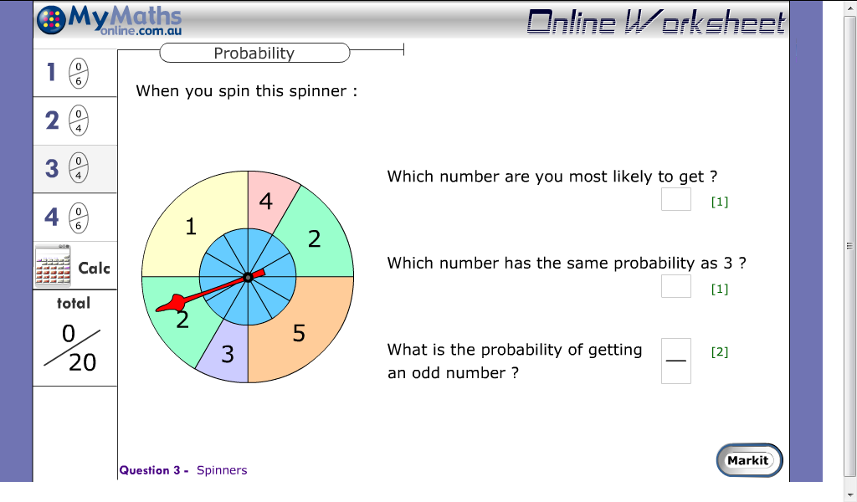

Question 6: [2 marks]
A Year 8 Science class is studying weather and climate. They measure the temperature every day for five days. The results are shown in the column graph below.
Temperature (°C) | 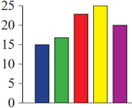
 | M T W T F

a) On which day did they record the highest temperature?
a) Monday b) Tuesday c) Wednesday d) Thursday e) Friday

b) What was the difference between the temperatures on Friday and Tuesday?
a) 3°C b) 8°C c) 13°C d) 18°C e) 23°C

END OF NON-CALCULATOR SECTION

Section 2 Calculator Allowed
Name: _________
Time: 35 minutes Marks: 30 marks
Question 1: [4 marks, ½ each]
Calculate the measures of centre (mean, median and mode) and range for the following data sets.
- 2, 2, 2, 3, 3, 4, 4, 5, 6  Mean= ____  Median=_____  Mode=_____  Range=_______ | - 20, 23, 21, 23, 26, 27,  Mean= ____  Median=_____  Mode=_____  Range=_____

Question 2: [4 marks: 3,1]
The following list shows the number of goals kicked each game by Perth Glory in the A-league this season.
0, 2, 1, 2, 2, 1, 2, 2, 4, 1, 2, 1, 3, 1, 1, 0, 2, 1, 1
- Put the scores into a dot plot

- Which amount of goals has the Glory scored most often?

Question 3: [8 marks: 3, 1, 4]
At a particular school the grades are given according to this guide:
Mark | 0-19 | 20-39 | 40-59 | 60-79 | 80-100
Grade | E | D | C | B | A

On a recent Year 8 Statistics test, a class of 24 students received the following marks:
72 | 85 | 56 | 82 | 75 | 34 | 60 | 47 | 88 | 64 | 25 | 91
43 | 97 | 79 | 16 | 90 | 54 | 71 | 68 | 39 | 58 | 83 | 75

a Complete the frequency table below.
Mark | 0–19 | 20–39 | 40–59 | 60–79 | 80–100
Tally
Frequency

b How many students received an A or B for this statistics test?

c Plot the results on a histogram.

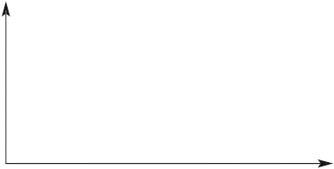

Question 4: [4 marks: 1 each]
Circle the outlier is each set of data.

- 2, 2, 3, 4, 4, 5, 5.5, 6, 21

- 12, 30, 34, 35, 35, 36, 37, 39, 40

- 150, 175, 140, 163, 192, 46, 163, 146

- 0.3, 0.4, 0.24, 0.33, 0.2, 0.15, 1.6, 0.45

Question 5: [7 marks: 2, 1, 2, 2]
Alex wanted to test his mental math skills by completing a test every week for 10 weeks.
Each test contained 20 questions and he record
Test | 1 | 2 | 3 | 4 | 5 | 6 | 7 | 8 | 9 | 10
Score | 15 | 16 | 16 | 17 | 19 | 2 | 17 | 18 | 19 | 17

- Calculate the Mean and Median

- Which score is the outlier?

- Remove the outlier and calculate the mean and median.

- If the outlier wasn’t removed which measure of centre would be more beneficial for Alex to use to help him work out how good he is at mental maths? Why?

Question 6: [3 marks]
A bag of marbles contains 9 marbles; 4 red, 3 blue and 2 yellow marbles. If you pick a marble at random determine the probability of choosing;

- A Yellow marble

- A blue marble

- Not a blue marble

End of Test

